

BIT3208 Weekly Logbook

COVER PAGE
Student Name: Marciah Muringi Gichohi
Admission Number: BSCCS/2024/53659
Course/Class: BIT Year 3
Unit Code: BIT3208
Unit Name: Advanced Web Design and Development
Lecturer Name: Mr. Michael Nyoro
Semester/Academic Year: Semester 1 / 2025–2026
Project Title: SmartShop – E-Commerce Web Application
Selected Technologies: Node.js, Express.js, MySQL, EJS Templating, HTML5, CSS3, JavaScript
GitHub Repository Link:
https://github.com/gichohimarciah-hub/smartshop-bit3208

Table of Contents
COVER PAGE 1
WEEK 1: Local Environment Setup 2
WEEK 2: Wireframes and GUI Design 5
WEEK 3: JavaScript and PHP Basics 9
WEEK 4: Server-Side Components 12
WEEK 5: Database Components and CRUD Operations 15
WEEK 8: Object-Oriented Modelling – UML Diagrams 25

WEEK 1: Local Environment Setup
Title: Installation and Testing of Local Development Environment

Fig 1: XAMPP Installation
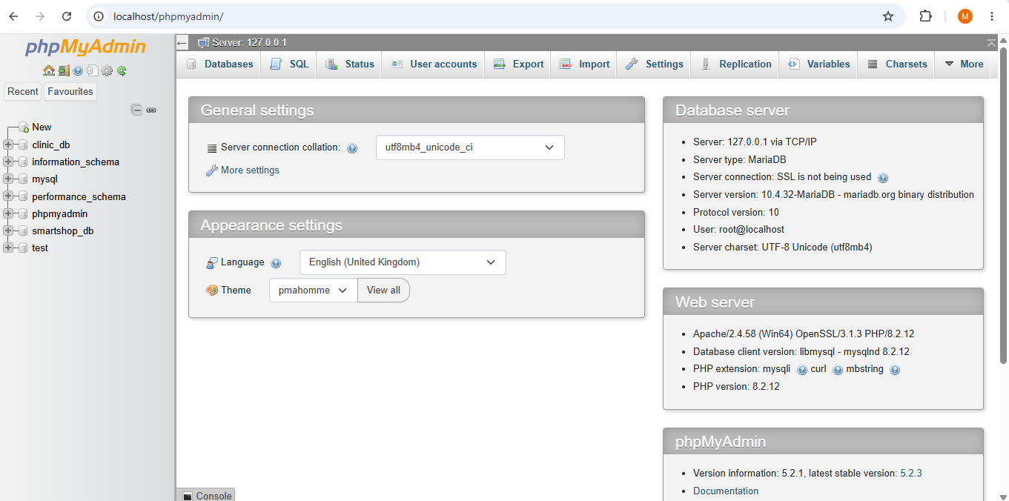
Fig 1: XAMPP installed and opened successfully on Windows.

Fig 2: Apache and MySQL Running
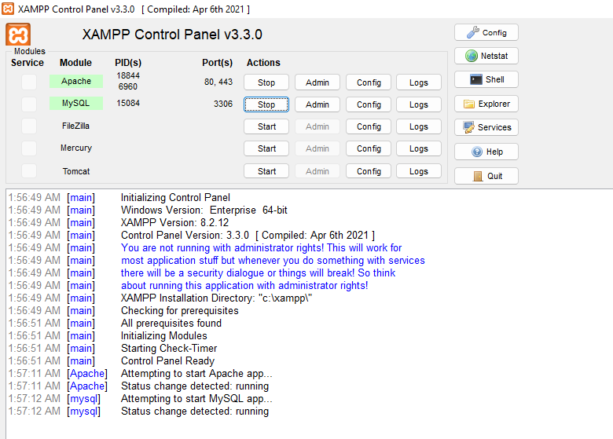
Fig 2: Apache and MySQL services started and running in XAMPP Control Panel.

Fig 3: Localhost Test Page
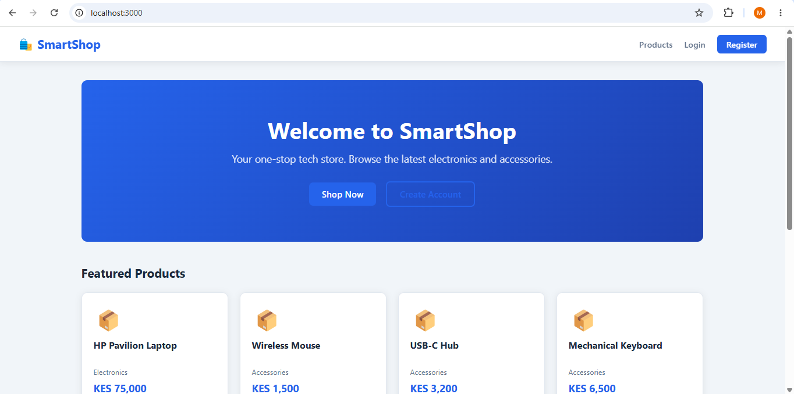

Fig 3: XAMPP localhost test page confirming Apache server is active.

Fig 4: Project Folder Structure in VS Code
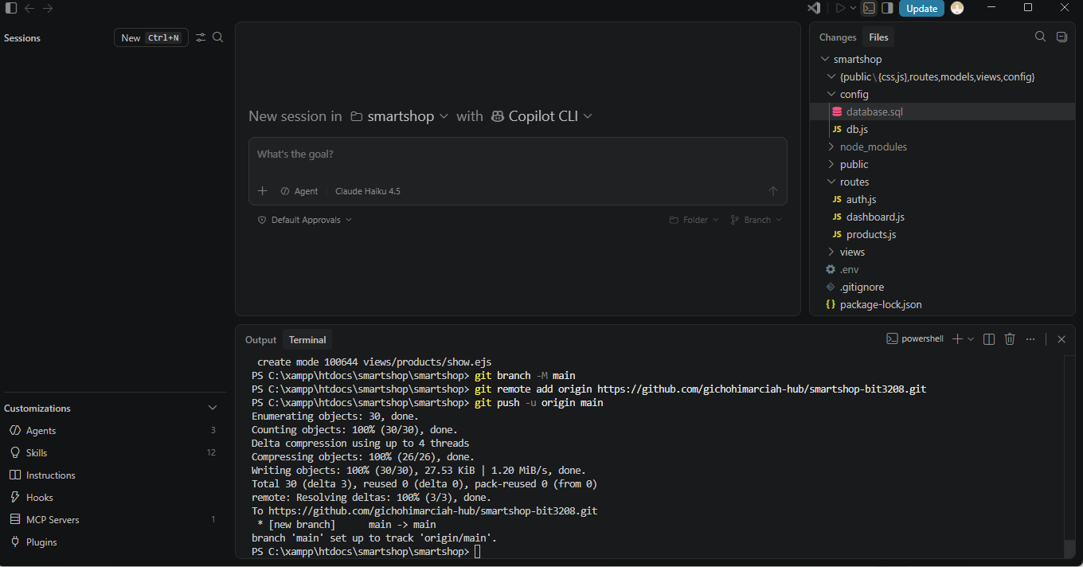
Fig 4: SmartShop project folder structure opened in VS Code showing config, routes, views, and public directories.

Fig 5: Database Connection Test
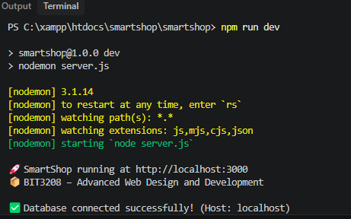
Fig 5: Node.js terminal output confirming successful MySQL database connection using the connection string in config/db.js.

Student Reflection
This week I set up the local development environment for SmartShop. Installing XAMPP gave me both Apache and MySQL, and getting both running as shown in Fig 2 confirmed my machine was ready. I organized the project into separate folders for config, routes, views, and public from the start, making future development easier to manage as seen in Fig 4. The highlight was Fig 5 — seeing "Database connected successfully" in the terminal meant Node.js had successfully read the credentials from the .env file and connected to MySQL. Without this step working, the rest of the project would not be possible.

WEEK 2: Wireframes and GUI Design
Title: User Interface Planning and System Design
Fig 1: SmartShop Home Page
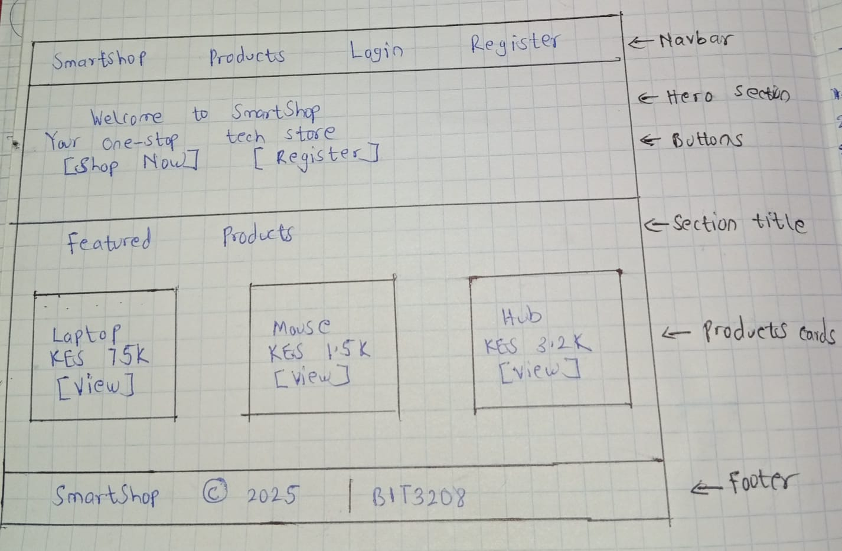

Fig 1: SmartShop home page with hero banner and featured product grid.

Fig 2: Dashboard Layout Design

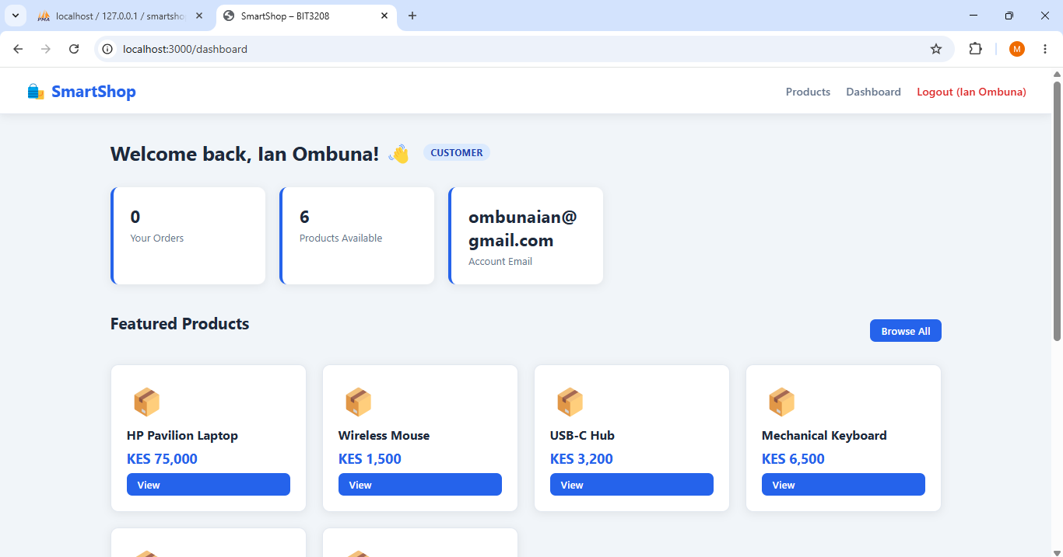

Fig 2: Customer dashboard displaying stats cards for orders, products available, and account email.

Fig 3: Products Listing Page
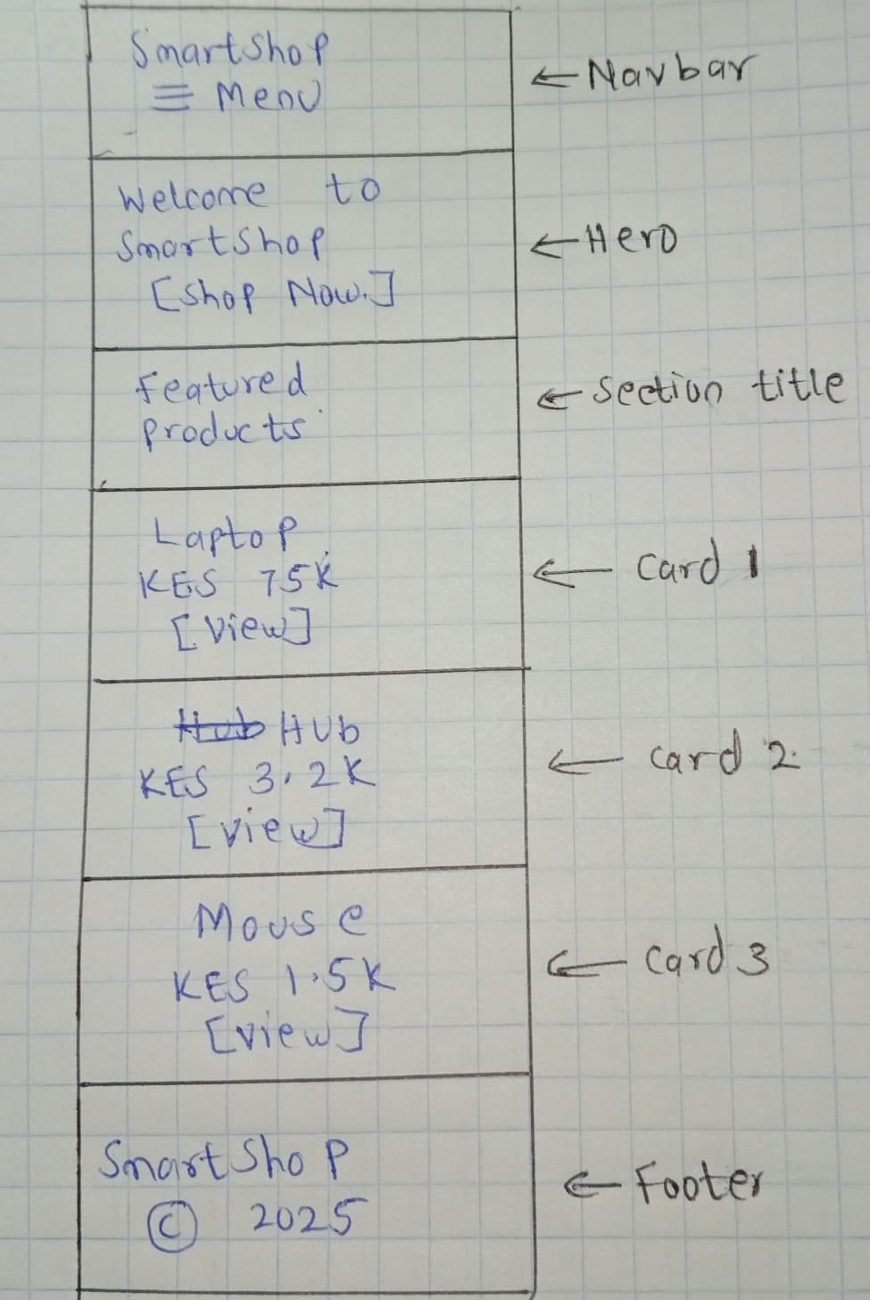

Fig 3: Products listing page with search bar, category filter, and responsive product cards.

Fig 4: Colour Theme and Navigation Structure
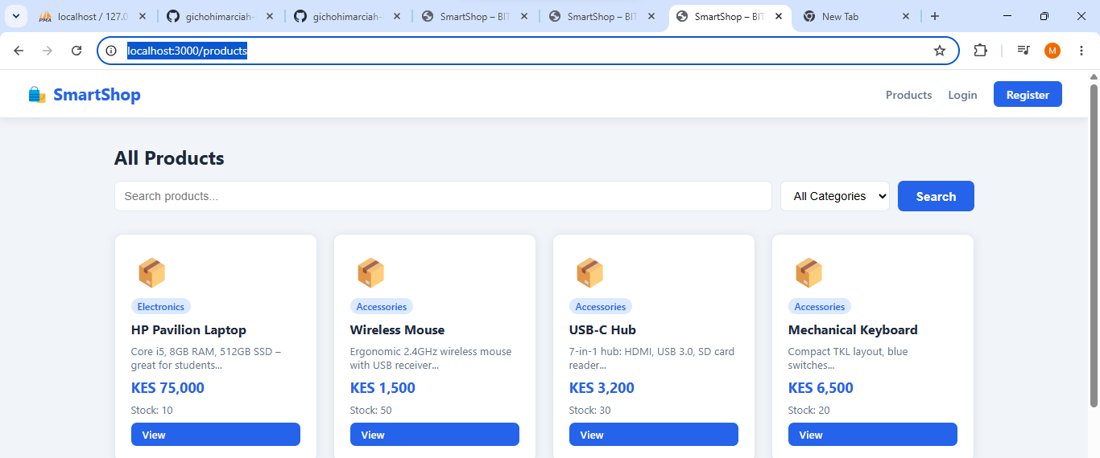
Fig 4: Navigation bar showing SmartShop branding, Products, Dashboard, Admin, and Logout links.

Fig 5: Admin Panel Layout
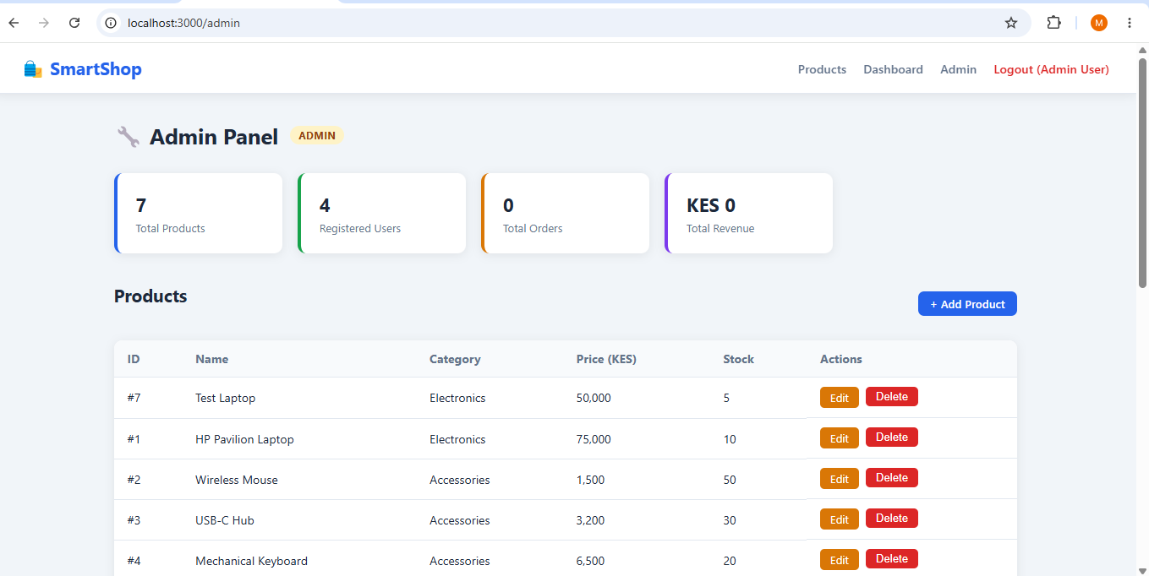

Fig 5: Admin panel displaying statistics dashboard with total products, registered users, total orders, and total revenue.

Student Reflection
This week I focused on designing the SmartShop interface for different user types. The navbar in Fig 4 adapts based on role — admin users see an extra Admin link that customers do not. The home page in Fig 1 uses a hero section and product grid to create a strong first impression. The dashboard in Fig 2 displays key user information immediately after login, reducing unnecessary navigation. The admin panel in Fig 5 summarizes the whole system at a glance with statistics cards. The blue color theme used throughout was a deliberate choice to give the application a clean and professional appearance.

WEEK 3: JavaScript and PHP Basics
Title: Frontend Interaction and Backend Foundations

Fig 1: JavaScript Form Validation – Login Page
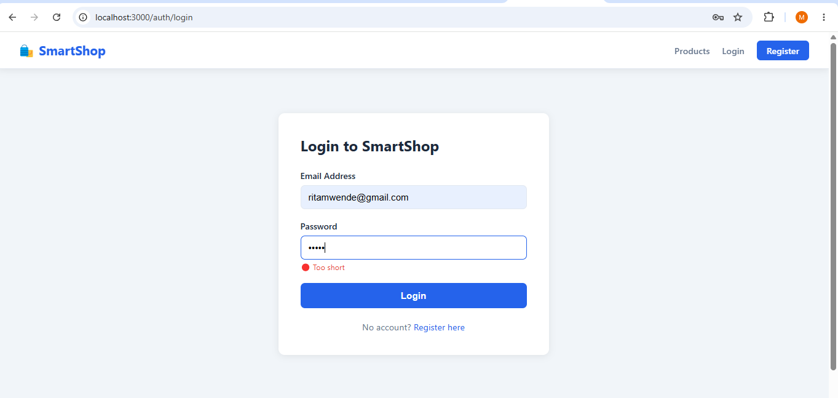
Fig 1: Login form JavaScript validation preventing submission when password is under 6 characters.

Fig 2: Password Strength Checker – Register Page
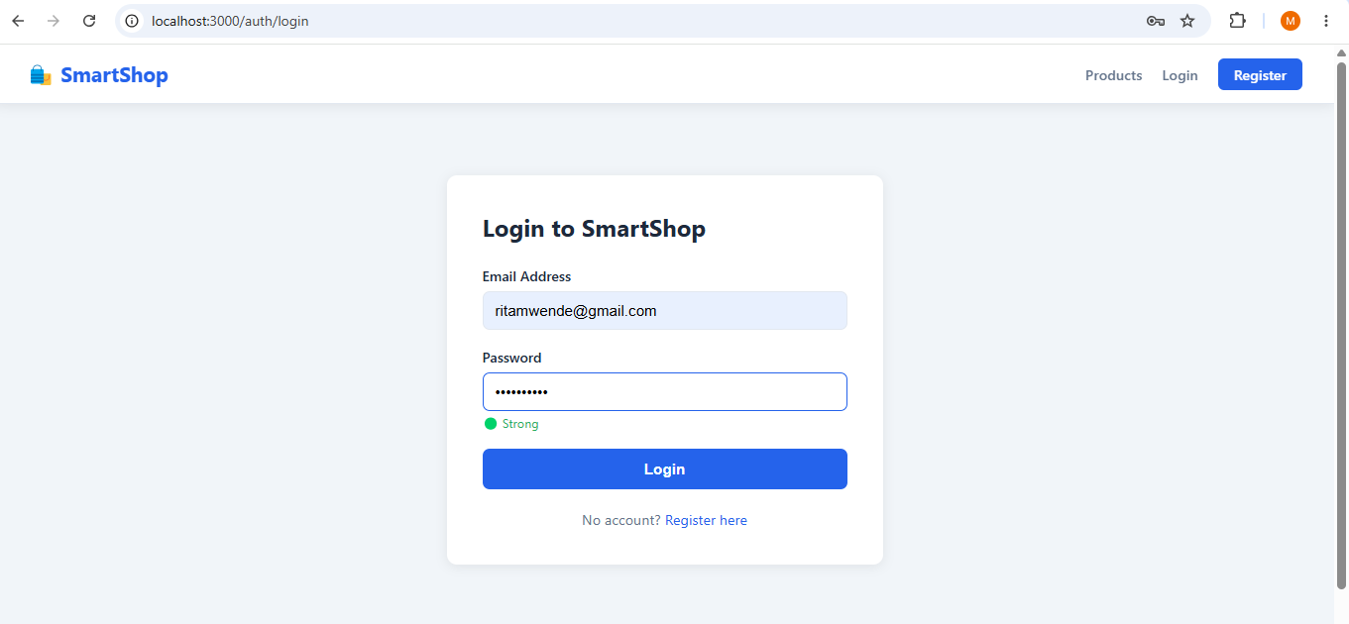
Fig 2: Password strength checker dynamically updating the progress bar colour from red (weak) to green (strong) as the user types.

Fig 3: Database Connection Script in VS Code
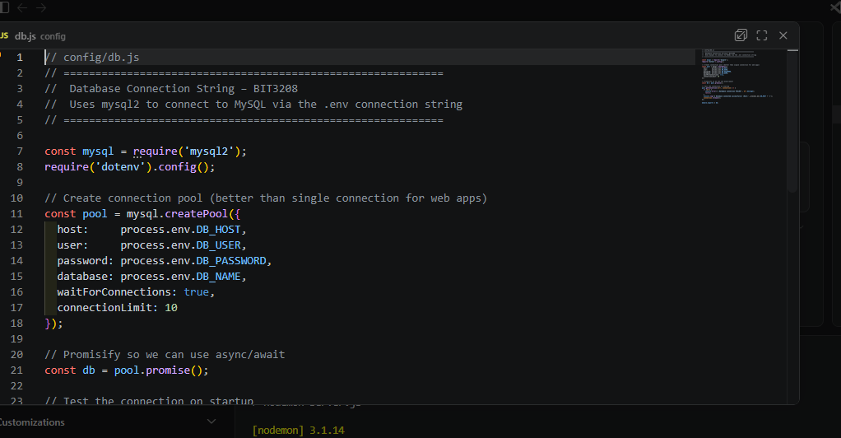
Fig 3: Database connection string in config/db.js using mysql2 connection pool with credentials loaded from .env file.

Fig 4: env File Showing Connection String
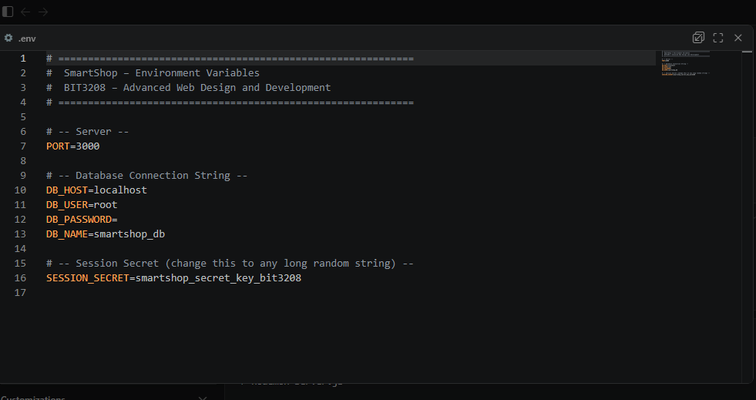
Fig 4: Environment variables file storing the database connection string securely, separated from application code.

Fig 5: Dynamic User Input Handling – Register Form
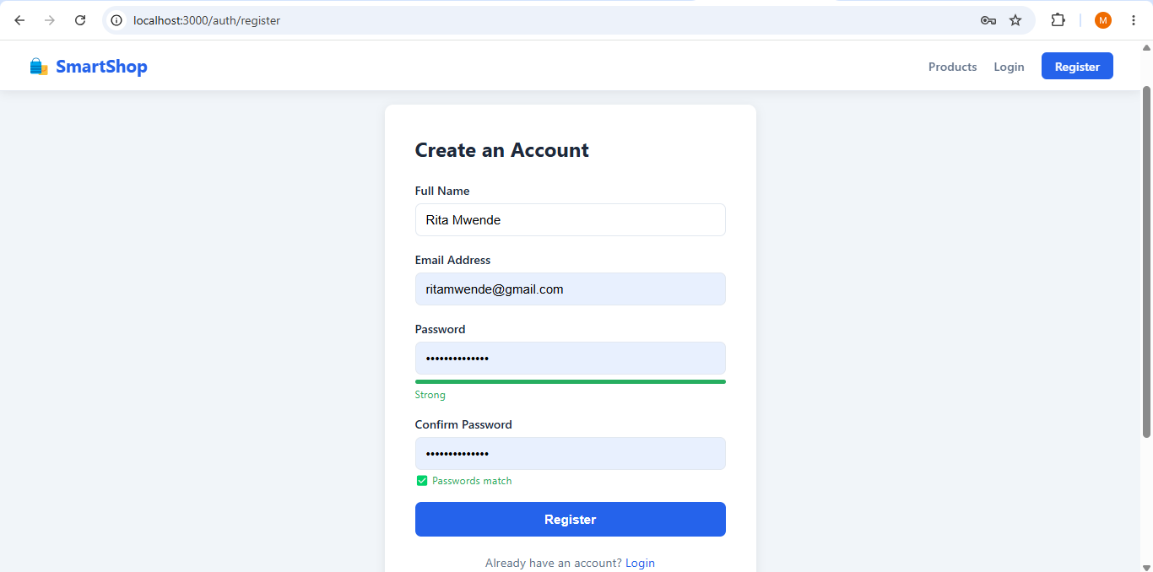
Fig 5: Real-time password match checker displaying green confirmation when both password fields match.

Student Reflection
This week I built frontend interactivity and the backend database connection. I implemented a login validation in Fig 1 that checks password length before submission and a password strength checker in Fig 2 that updates a progress bar in real time as the user types. Fig 5 shows a password match checker confirming both fields are identical. On the backend, Fig 4 shows the .env file storing database credentials securely as environment variables, keeping sensitive information out of the source code. Fig 3 shows config/db.js using these credentials to create a MySQL connection pool that handles multiple requests efficiently.

WEEK 4: Server-Side Components
Title: Backend Development and Authentication System

Fig 1: User Registration Form

Fig 1: User registration form collecting name, email, password, and confirm password fields.

Fig 2: Registered User Appearing in phpMyAdmin
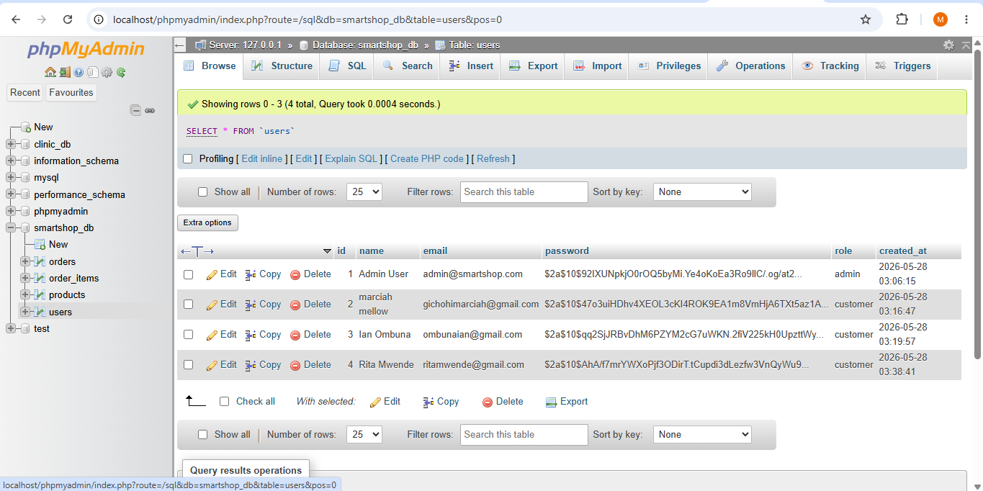

Fig 2: phpMyAdmin users table showing a registered user with their password stored as a bcrypt hash, not plain text.

Fig 3: Auth Routes Code in VS Code
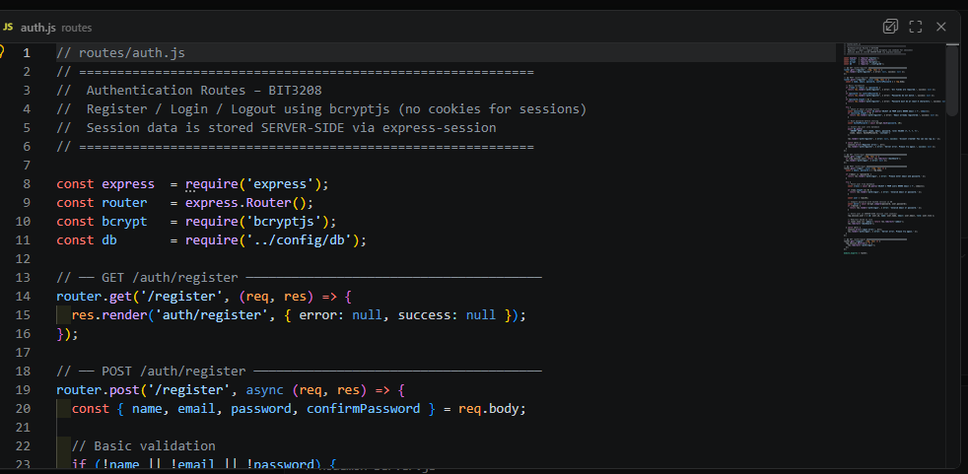
Fig 3: Authentication routes in routes/auth.js handling user registration, login, and logout using bcryptjs for password hashing.

Fig 4: Session Configuration in server.js
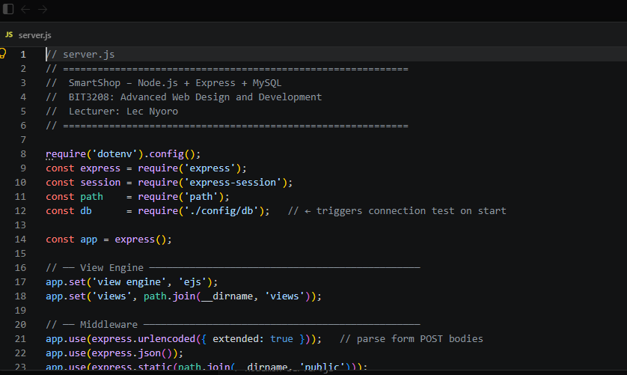
Fig 4: Server-side session configuration in server.js using express-session. Session data is stored on the server, not in browser cookies.

Fig 5: Customer Dashboard After Successful Login
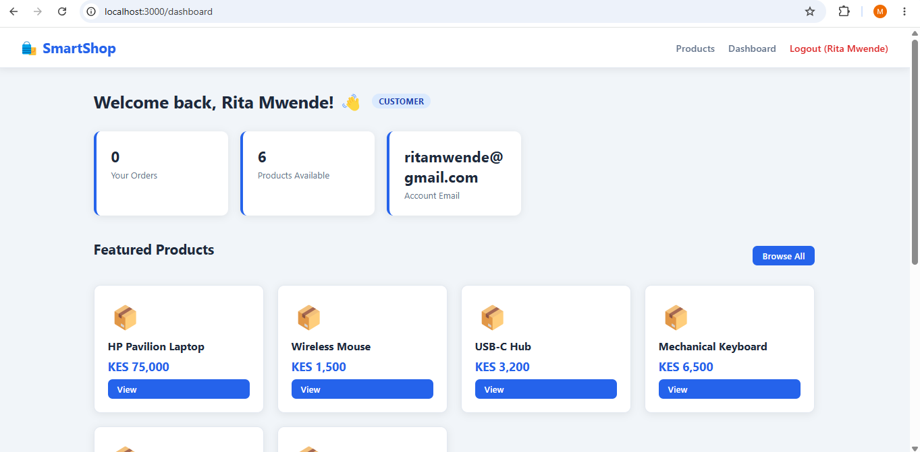
Fig 5: Customer dashboard displayed after successful login, confirming session-based authentication is working correctly.

Student Reflection
This week I built the authentication system. When a user registers, bcryptjs hashes their password before saving it — Fig 2 shows hashed values in phpMyAdmin starting with $2a$, confirming plain text passwords are never stored. Fig 3 shows routes/auth.js handling registration, login, and logout. On login, bcrypt. compare () checks the submitted password against the stored hash. If correct, user details are saved to a server-side session as configured in Fig 4 — only a session ID reaches the browser, satisfying the no cookie-based session storage requirement. Fig 5 confirms everything works with the personalised dashboard appearing after a successful login.

WEEK 5: Database Components and CRUD Operations
Title: Database-Driven Application with Full CRUD

Fig 1: smartshop_db Database with 4 Tables in phpMyAdmin

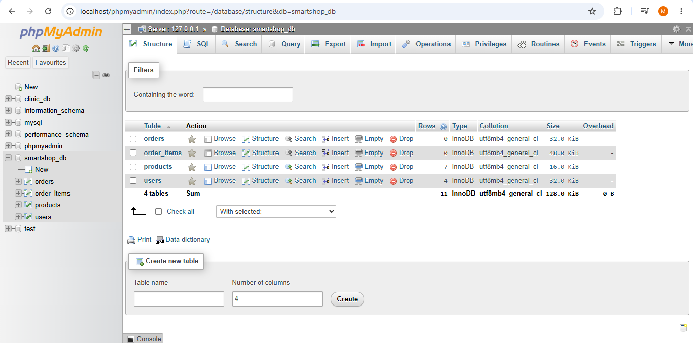
Fig 1: phpMyAdmin showing the smartshop_db database with all four tables: orders, order_items, products, and users.

Fig 2: Add Product Form (Create Operation)

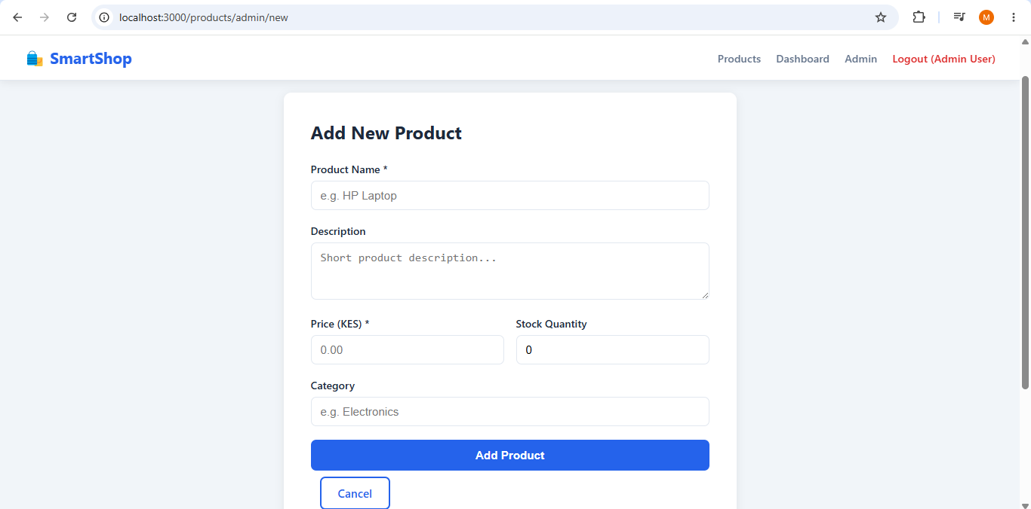
Fig 2: Admin product creation form demonstrating the Create operation of the CRUD cycle.

Fig 3: Products Table in phpMyAdmin After Adding Product
[INSERT SCREENSHOT – phpMyAdmin products table showing the newly added product as a new row]
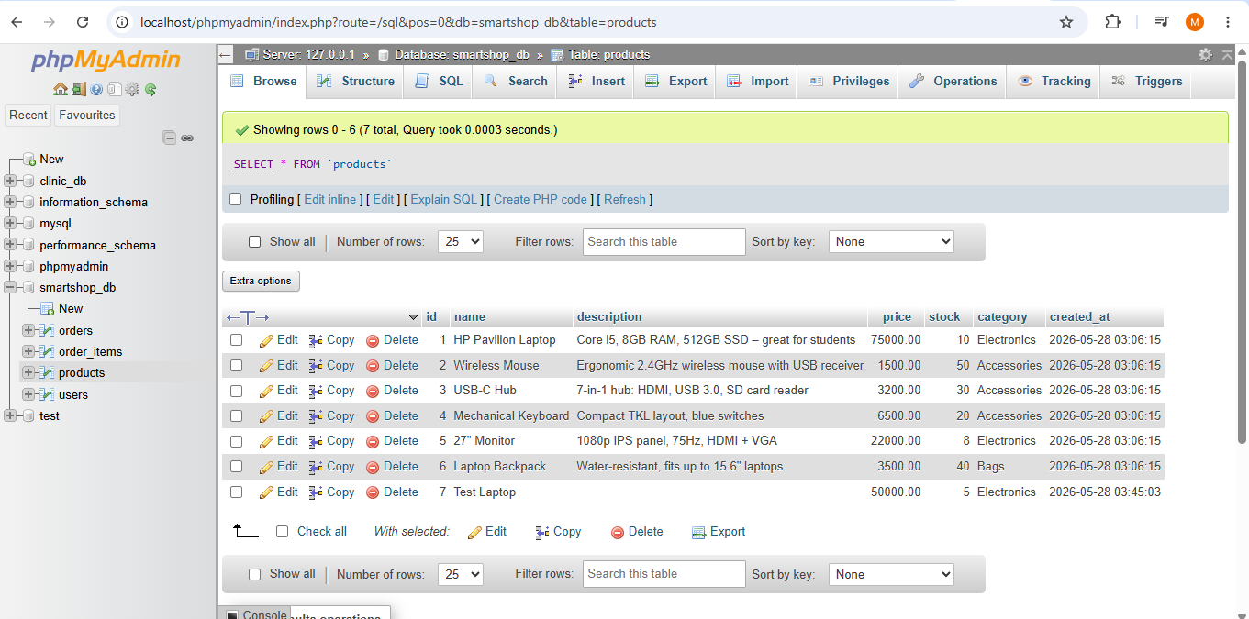
Fig 3: phpMyAdmin products table confirming the new product was successfully saved to the database after form submission.

Fig 4: Admin Panel with Edit and Delete Buttons
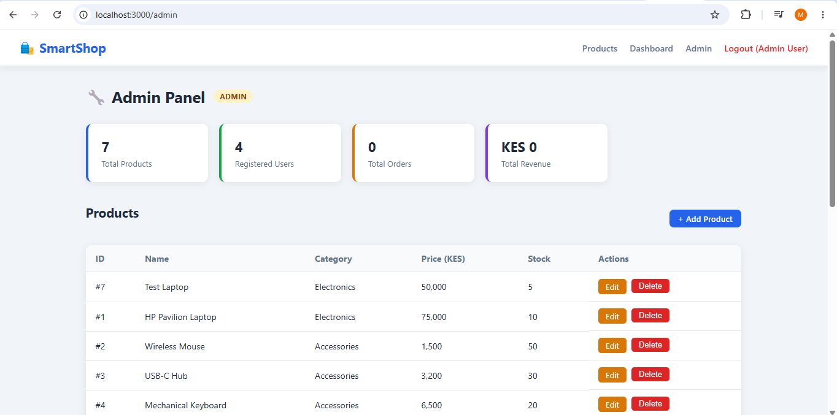
Fig 4: Admin panel showing all products with Edit and Delete action buttons, completing the full CRUD functionality.

Fig 5: GitHub Repository with All Project Files
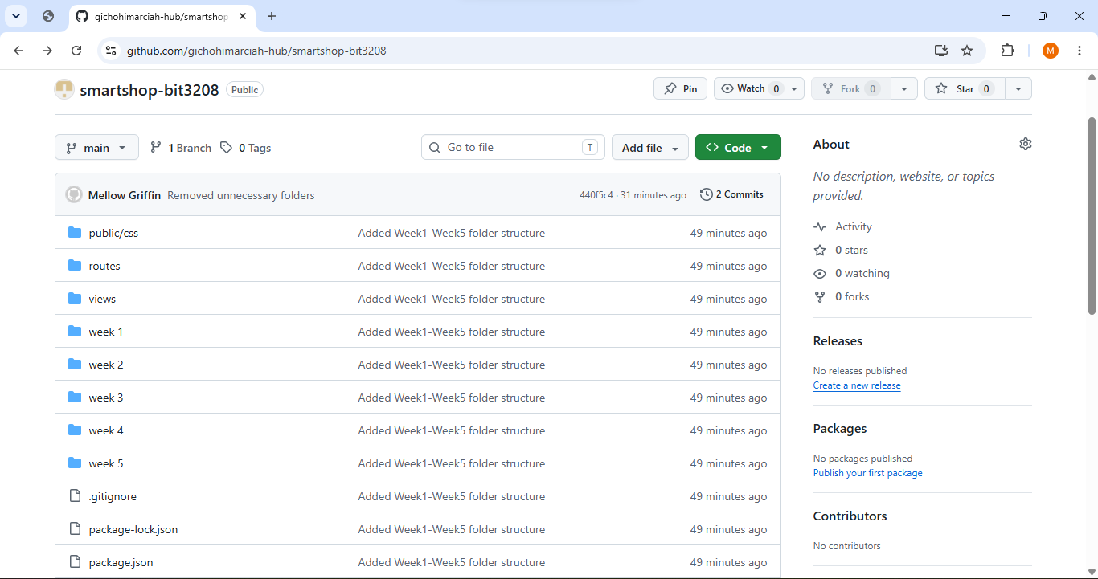
Fig 5: GitHub repository showing all SmartShop project files successfully pushed and available for review.

Student Reflection
This week I completed the project by implementing full CRUD operations. Fig 1 shows smartshop_db in phpMyAdmin with all four tables forming the complete data structure. The key demonstration was the Create operation — after filling the product form in Fig 2, the new product immediately appeared in phpMyAdmin as shown in Fig 3, confirming the frontend and database were properly connected. Fig 4 shows the admin panel with Edit and Delete buttons completing the full CRUD cycle on live data. Fig 5 shows the project pushed to GitHub, meaning all my work is documented, version controlled, and accessible for review.
BIT3208 – Advanced Web Design and Development
Student: Marciah Muringi Gichohi | Admission No: BSCCS/2024/53659

WEEK 7: Architecture & Design -N-Tier System Design
Title: Architecture & Design -N-Tier System Design

Fig 1: SmartShop N-Tier Architecture Diagram
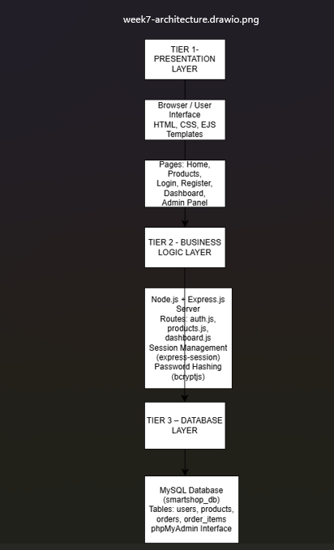
Fig 1: Three-tier architecture diagram for SmartShop showing the Presentation Tier (browser/EJS views), Application Tier (Node.js/Express server and routes), and Data Tier (MySQL database), created in Draw.io.
Fig 2: Folder Structure Reflecting N-Tier Separation
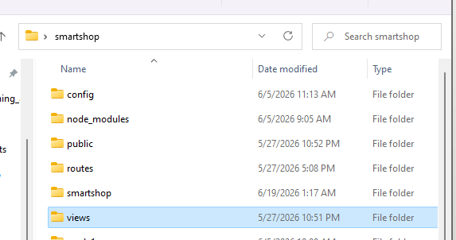
Fig 2: SmartShop project folder structure in VS Code showing views/ (Presentation Tier), routes/ (Application Tier), and config/db.js (Data Tier) as separate layers.
Fig 3: Middleware and Route Handler in server.js
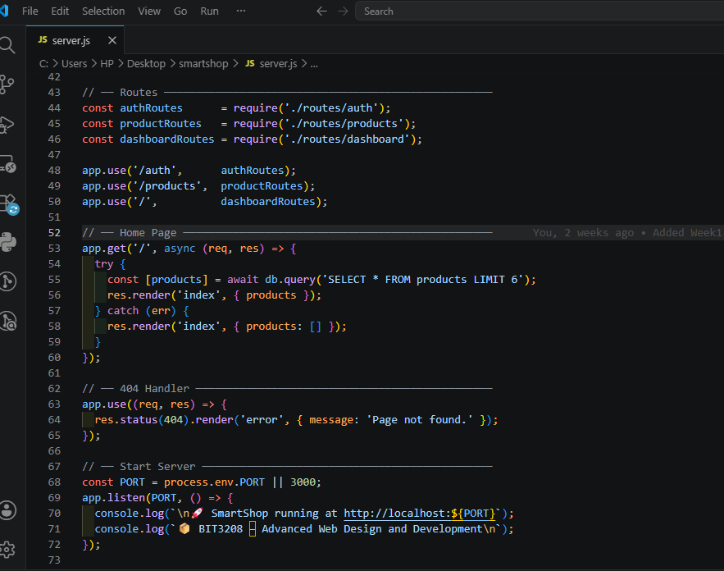
Fig 3: server.js showing middleware setup and route mounting that forms the Application Tier — handling requests between the browser and the database.
Fig 4: Security Implementation – requireLogin Middleware
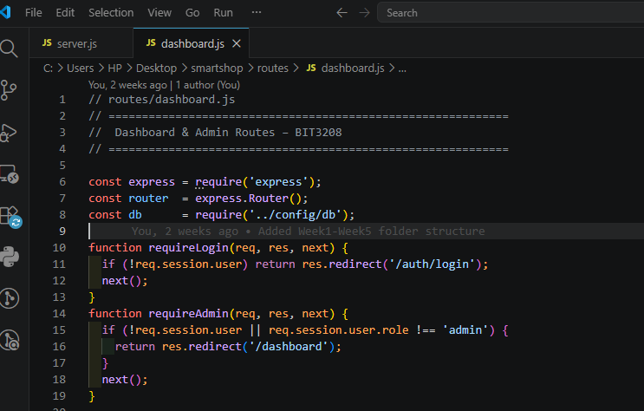
Fig 4: requireLogin and requireAdmin middleware functions in routes/dashboard.js enforcing role-based access control as a security layer within the Application Tier.
Fig 5: SmartShop Running at localhost:3000

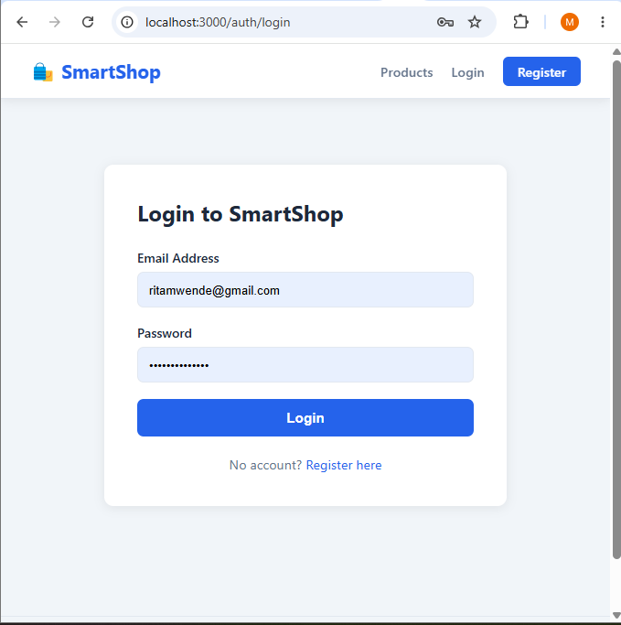
Fig 5: SmartShop running successfully at localhost:3000 in the browser, demonstrating that all three tiers are communicating correctly in the local development environment.
Student Reflection
This week I focused on the architectural design of SmartShop using the N-Tier model. The Draw.io diagram in Fig 1 made it clear how the three layers communicate — the browser sends a request, Express routes it through the Application Tier, and MySQL responds with data before EJS renders the result back to the user. Fig 2 shows this separation physically in the folder structure, where views/, routes/, and config/ each represent a distinct tier. Fig 3 demonstrates the Application Tier in action through server.js middleware and route mounting. The security layer in Fig 4 sits within the Application Tier, ensuring unauthenticated users cannot access protected routes. Fig 5 confirms that the full three-tier system is operational. Understanding N-Tier architecture this week helped me see why separating concerns in code is important for both maintainability and security.

WEEK 8: Object-Oriented Modelling – UML Diagrams
Title: Object-Oriented Modelling – UML Diagrams for SmartShop

Fig 1: Use Case Diagram – SmartShop System
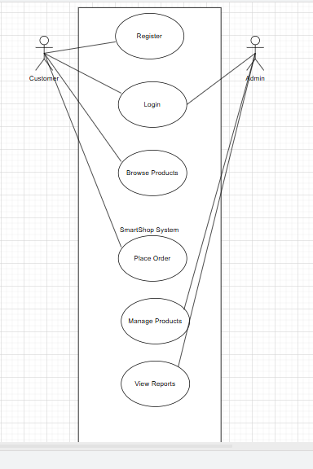
Fig 1: UML Use Case Diagram showing the two actors (Customer and Admin) and their interactions with the SmartShop system — including Register, Login, Browse Products, Place Order, Manage Products, and View Reports.
Fig 2: Class Diagram – SmartShop Data Models
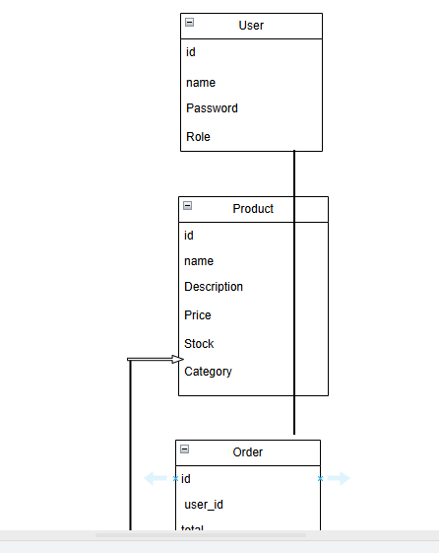

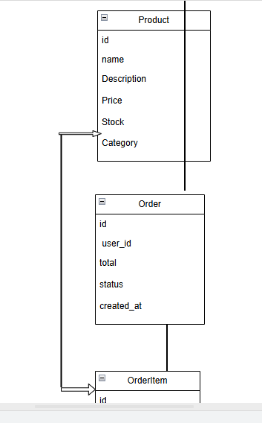
Fig 2: UML Class Diagram mapping the four SmartShop database tables (User, Product, Order, OrderItem) as classes with their attributes and relationships — User places many Orders, Order contains many OrderItems, each linked to a Product.
Fig 3: Sequence Diagram – User Login Flow
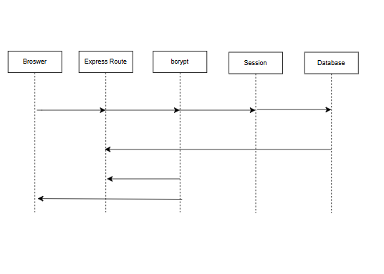
Fig 3: UML Sequence Diagram showing the message flow during user login — from the browser submitting credentials, through the Express route, bcrypt password comparison, session creation, and final redirect to the dashboard.
Fig 4: Activity Diagram – Place Order Process
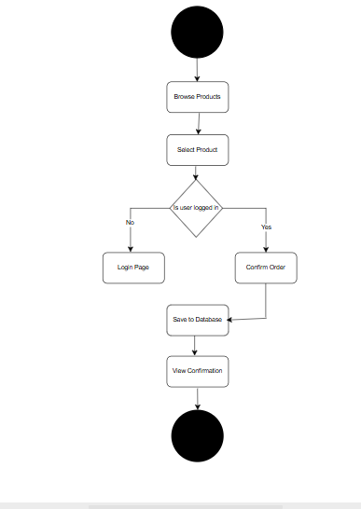
Fig 4: UML Activity Diagram illustrating the steps a customer follows to place an order — Browse Products, Select Product, Login Check, Confirm Order, Save to Database, and View Confirmation.
Fig 5: Draw.io UML Workspace Showing All Diagrams
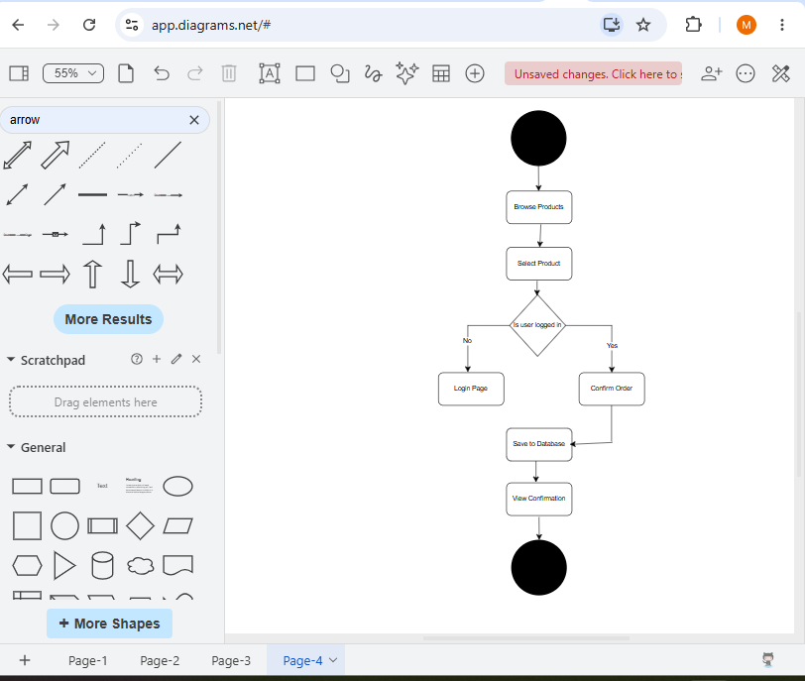
Fig 5: Draw.io workspace showing all four UML diagrams (Use Case, Class, Sequence, Activity) created for the SmartShop system, saved as a .drawio file and exported as PNG images.
Student Reflection
This week I applied Object-Oriented Modelling to SmartShop by creating four UML diagrams in Draw.io. The Use Case Diagram in Fig 1 helped me define system boundaries clearly — separating what a Customer can do from what only an Admin can access. The Class Diagram in Fig 2 mapped directly onto my database schema, confirming that the four tables I built in Week 5 reflect a proper object-oriented data model with associations. The Sequence Diagram in Fig 3 traced the exact execution path of the login process, which helped me understand how bcrypt, sessions, and routes interact at runtime. The Activity Diagram in Fig 4 modelled the order placement workflow, revealing that a login check must happen before an order can be saved. Fig 5 shows all four diagrams together in Draw.io. This exercise made the SmartShop system easier to reason about as a whole and would be valuable documentation for anyone maintaining or extending the application in future.
BIT3208 – Advanced Web Design and Development
Student: Marciah Muringi Gichohi | Admission No: BSCCS/2024/53659

